**Waterfall model ( you can’t go back and change things later )**

Requirement analysis

System design

Implementation ( coding )

Testing

Deployment

Maintenance

Advantages of waterfall model:

1. Quality of product will be good.
2. Since changes are not allowed obviously we will have less bugs.
3. Initial investments are also less since testers are hired at a later stage.
4. Preference for smaller projects which are less or not at all dynamic in nature.

Disadvantage:

1. Requirement design not allowed
2. If there is a defect found in first stage it will be carried along

SPIRAL model :

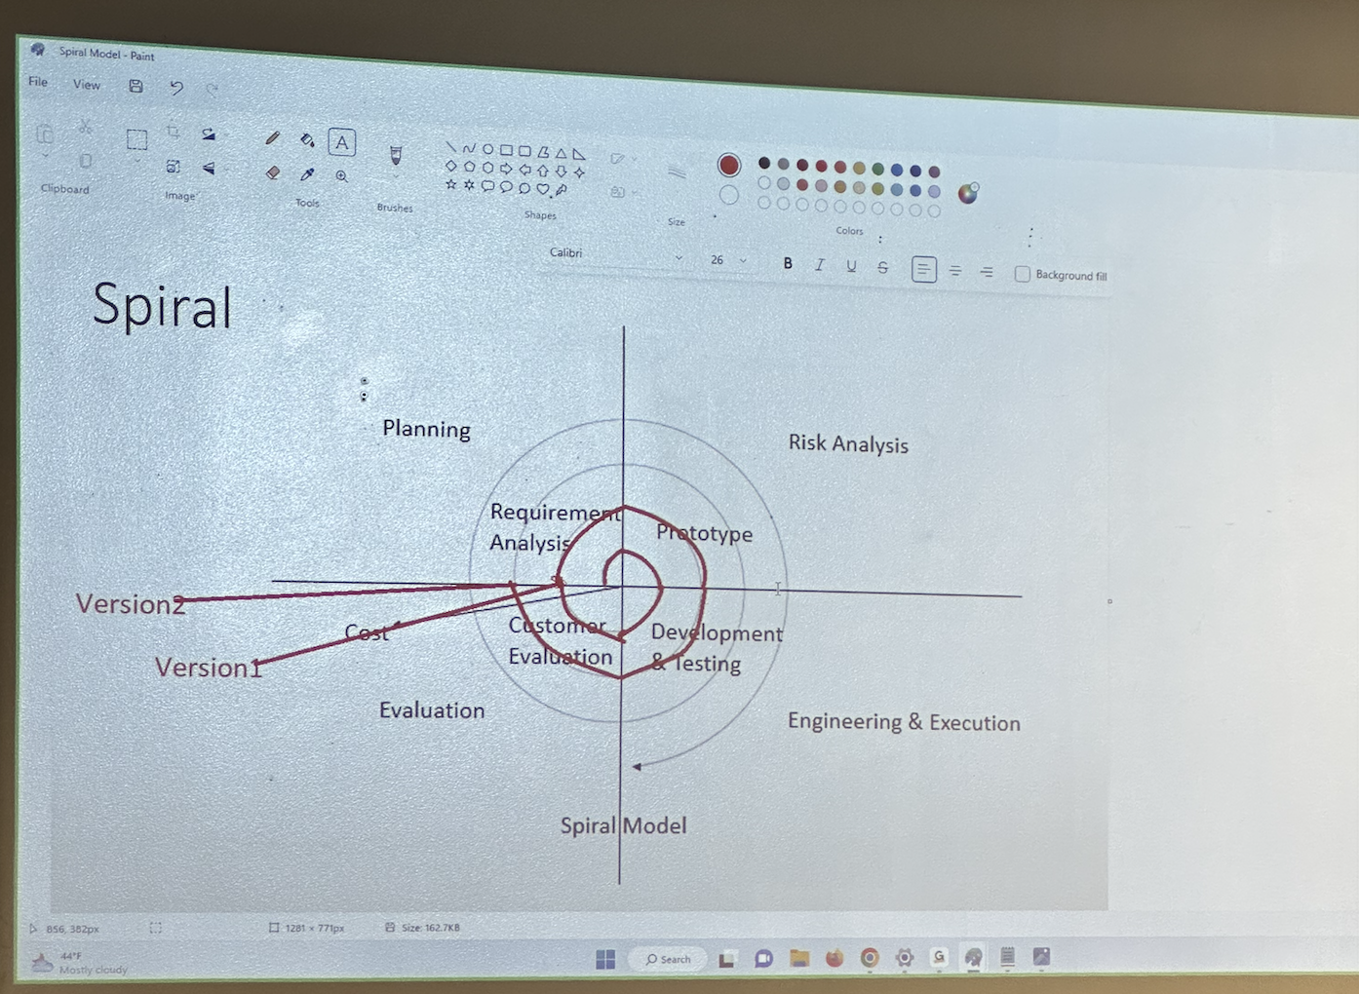

Advantage:

Testing is done for every cycle

Customer will get to use the software for every version ( version 1, version 2, version 3………)

Change in requirements are accommodated

Disadvantage:

Testing was not possible till the end ??

V MODEL : verification model validation model

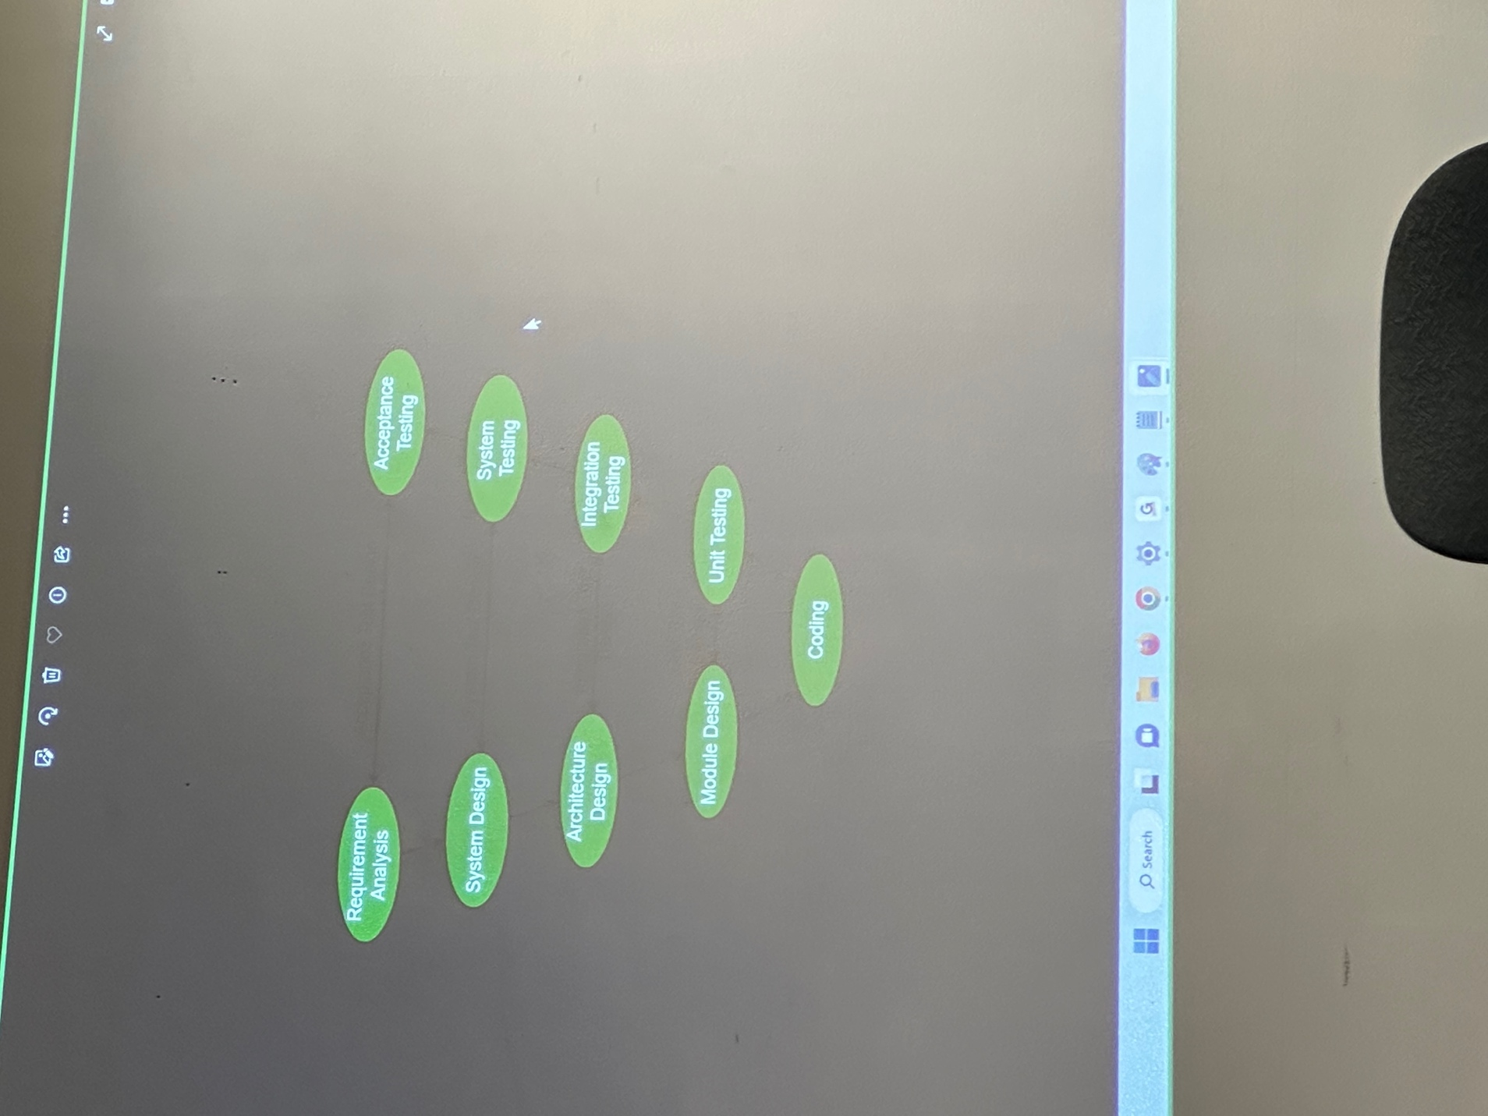

Disadvantage :

Cost money cause u will need to hire a lot of people together from the beginning.

QA VS QA VS QE

Q Assurance is process related

Q control is software testing

Q Engineering/Engineer is automation software tester

Software testing:

Static:

Reviews

Inspection ( formal review whats wrong whats not complete)

Walkthroughs